Lesson 5

Graphs of Trigonometric Functions

sPECIFIC OBJECTIVES:

At the end of the lesson, the student is expected to:
- Identify the amplitude, period, phase shift and vertical shift of a sine or cosine function.
- Sketch the graph of sine and cosine function using its amplitude, period, phase shift and vertical shift.
- Graph the secant, cosecant, tangent and cotangent functions.

5.1 Graph of y = sin x

Properties of Sine Function Graph
- The graph crosses the x-axis at the initial point, endpoint and midpoint of a cycle. These points are called the zeros of the function.
- A maximum occurs midway between the first two zeros in the cycle, and a minimum occurs between the last two zeros. The maximum and the minimum values are determined by the amplitude.

Remarks:

- The graph of y = sin x is periodic meaning the curve repeats itself at a regular interval.
- The graph of the function through one period is called cycle. The period of sine function is 2.
- The amplitude represents the maximum variation of the curve from the x-axis. The amplitude of sine function is 1.

Graph of y = sin x

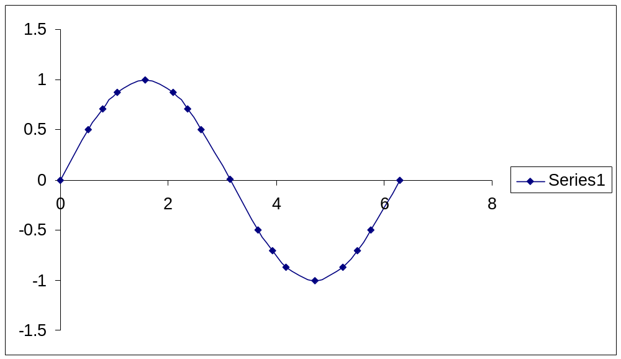

5.2 Graph of y = cos x
Properties of Cosine Function Graph
- A maximum occurs at the initial point and the endpoint of a cycle. A minimum occurs midway in the cycle. The maximum and the minimum values are determined by the amplitude.
- The zeros occur midway between the maximum and a minimum.

Remark:

- The graph of the cosine function has the same basic shape as y = sin x.
- The graph is also periodic, with period 2, and it has also an amplitude of 1.

Graph of y = cos x
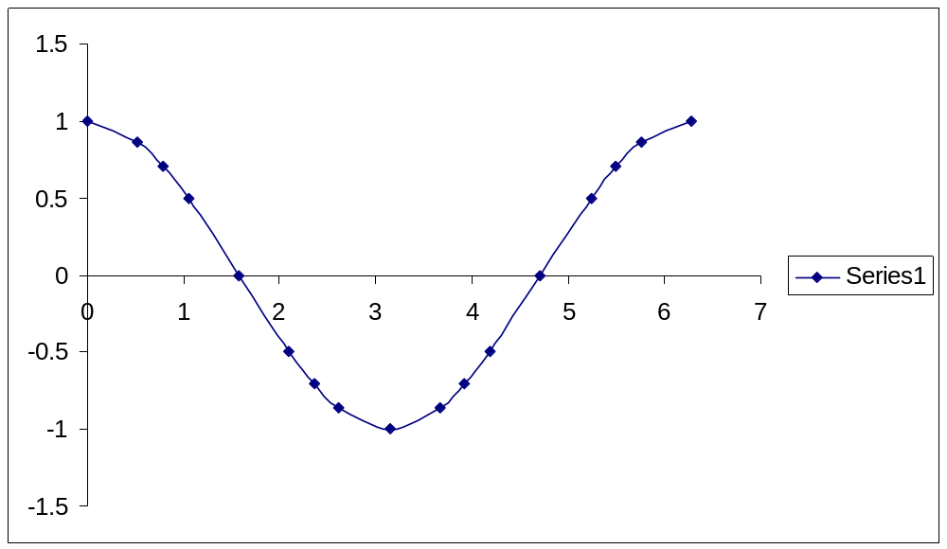

5.3 Graph of y = a sin bx or y = a cos bx

For y = a sin bx and y = a cos bx

The amplitude is 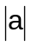. The period is 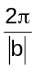
A negative sign before a inverts the graph.

Remarks:

- Multiplying the sine or cosine function by a constant changes only the amplitude and causes vertical stretch or compression of the basic graph.
- The maximum and the minimum values of the graph y = a sin bx and y = a cos bx are and -, respectively.

Graph of y = sin 2x
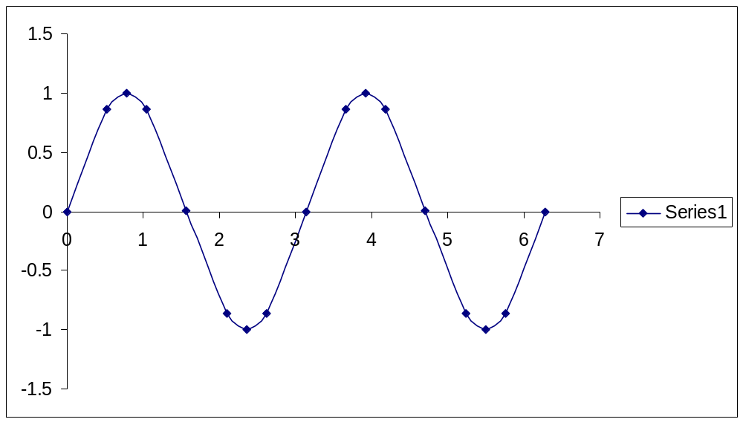

Graph of y = 3 sin 2x
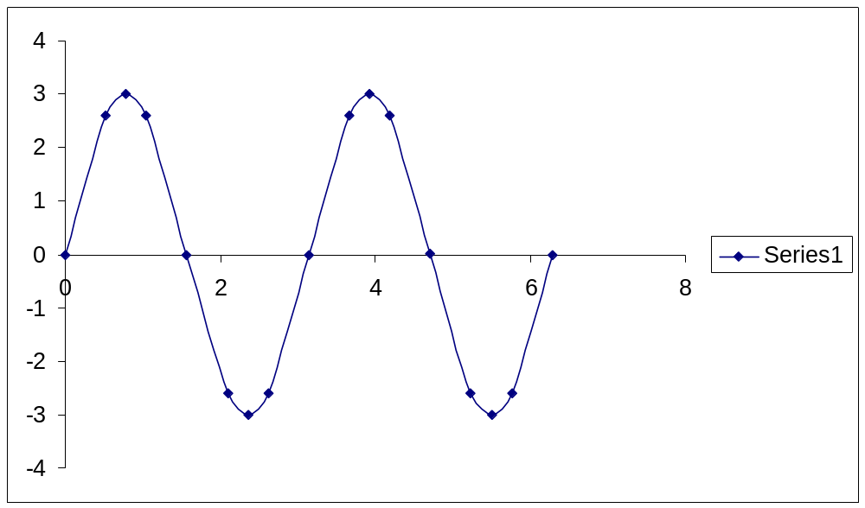

Exercise 5.3 Determine the amplitude and the period of each function. Then sketch the graph over the interval 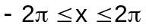.

a) y = 2 cos x c) y = 3 cos 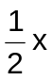
b) y = 3 sin 2x d) y = - 2 sin x

5.4 Graph of y = a sin b(x + c) + d or y = a cos b(x + c) + d

For y = a sin b(x + c) + d and y = a cos b(x + c) + d

The amplitude is . The period is

The phase shift from y = a sin bx or y = a cos bx is c units to the left if c > 0, and 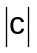 units to the right if c < 0.

The vertical shift from y = a sin bx or y = a cos bx is d units upward if d > 0, and 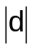 units downward if d < 0.

Remarks:

- The distance by which the graph is shifted to the right or to the left is called phase shift.
- The distance by which the graph is shifted up or down is called the vertical shift.

Example 5.4 Determine the amplitude, period, phase shift, and vertical shift of each function. Sketch the graph over the interval 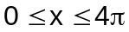.

a) 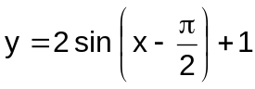 b) 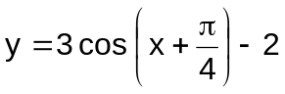

5.5 Graph of Tangent and Cotangent Functions

The tangent function is discontinuous, since its graph has breaks. Asymptotes occur at these breaks. The amplitude is not defined because tan x increases or decreases without bound as x approaches the asymptotes.

Since the tangent and cotangent functions are reciprocal functions, the value of cot s is undefined when tan x = 0, and it is zero when tan x is undefined.

Example 5.5 Graph the functions y = tan x and y = cot x

5.6 Graph of y = a tan b(x + c) + d or y = a cot b(x + c) + d

For y = a tan b(x + c) + d and y = a cot b(x + c) + d

The constant a vertically stretches or shrinks the graph compared to the graph of y = tan x or y = cot x.

The period is 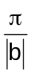.

The phase shift from y = a tan bx or y = a cot bx is c units to the left if c > 0, and units to the right if c < 0.

The vertical shift from y = a tan bx or y = a cot bx is d units upward if d > 0, and units to the right if d < 0.

Asymptotes have these equations:

For tangent functions, b (x + c) = 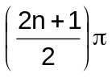, if n is an integer.

For cotangent functions, b (x + c) = 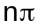, I f n is an integer.

5.7 Graph of Secant and Cosecant Functions

The graphs of secant and cosecant functions are discontinuous and have asymptotes since secant and cosecant functions are not defined when the values of cosine and sine, respectively, are equal to zero.

The amplitude is not defined because the graph increases or decreases without bound as x approaches the asymptotes.

Example 5.7 Graph the functions y = sec x and y = csc x.

5.8 Graph of y = a sec b(x + c) + d or y = a csc b(x + c) + d

For y = a sec b(x + c) + d and y = a csc b(x + c) + d

The constant a vertically stretches or shrinks the graph compared to the graph of y = sec x or y = csc x.

The period is .

The phase shift from y = a sec bx or y = a csc bx is c units to the left if c > 0, and units to the right if c < 0.

The vertical shift from y = a sec bx or y = a csc bx is d units upward if d > 0, and units to the right if d < 0.

Asymptotes have these equations:

For secant functions, b (x + c) = , if n is an integer.

For cosecant functions, b (x + c) = , I f n is an integer.

Exercises 5.8.1 Determine the period, the phase shift, and the vertical shift, if any, of each function. Describe any vertical stretching or shrinking.

a) 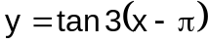 d) 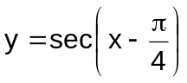
b) 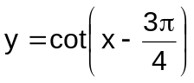 e) 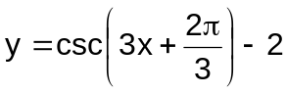
c) 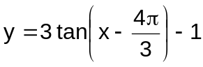 f) 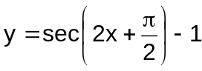

Exercises 5.8.2 Graph each of the following over a two-period interval:

a) 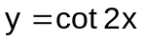 c) 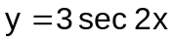

b) 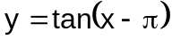 d) 